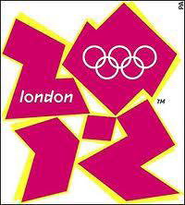
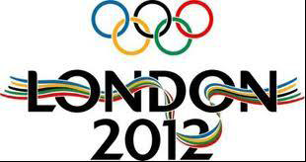
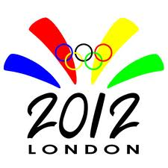
Ms.Ruth C.Hugh
Olympic 2012 Promotional Draw
London 2012 - One Churchill Place – Canary Wharf - London E14 5LN.
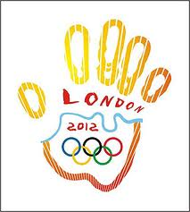
Attention: Winner,

2012 London Olympics Lottery Draws Notice

This is to inform you that London 2012 summer Olympic awareness and promotion company, and London 2012 summer Olympics Organizing Committee (LSOOC) here in London (U.K), has held an Internet Raffle Draw among all internet e-mail users, and your e-mail address was among the 10,000,000.00 (Ten million) e-mail addresses that was randomly picked by the computer during the Second Quarter Raffle Draw (SQRD).

We are therefore with great pleasure, to notify you that your e-mail address once again, happened to come out top number (1) out of the 10,000,000.00. (Ten million) e-mail addresses on the final ballot draw.

Please note that this has made you the jackpot winner of the sum of £800,000.00 (Eight hundred thousands British Pounds) and free entrance tickets to watch the games live in London. Be aware that this Internet Raffle Draw (IRD) was organized by London 2012 summer Olympic awareness and Promotion Company, and London 2012 summer Olympics Organizing Committee (LSOOC), to create awareness to the world, as England is finalizing their preparation for the hosting of the 2012 summer Olympics.
BELOW ARE YOUR WINNING DETAILS
COMPUTER DRAWS NUMBER: 177, WINNING UMBERS; 1970, WINNING INSURANCE POLICY NUMBER: JJA23UK, REFERENCE NUMBER: EAASL/941OY1/012, BATCH NUMBER: 12/27/Du3
PRIZE CLAIMING INSTRUCTION:
Your Fund is now deposited with our correspondent Paying Bank ABSA. Insured in your name for security reasons, you are advised to please keep your winning details very confidential from the members of the public to avoid double claim as your winning/payment will be cancelled should Two (2) claims be submitted under the above specified winning details.
Please note that claiming agents has been appointed in strategic areas around the world to help and ensure an easy and immediate claim to our entire lucky winner's. We have checked your location and you’re claiming falls under group B.
You are to call and forward you’re winning details to agent Dr. James Tukur.in Port Elizabeth (Eastern Cape Province) South Africa at +or E-mail him at jamestukur_70@hotmail.com. You at advised to send to him your contact details e.g names, telephone numbers, address, nationality.
To enable him clear your file for immediate payment. Visit: http://www.london2012.com for more details.
Dr. James Tukur.
E-mail Address: jamestukur_70@hotmail.com
Tel/Fax: + 27-785-544-338
Batch Number (#): 12/27/Du34
NOTE: visit: http://www.london2012.com / http://www.facebook.com/London2012

Congratulation’s
DR. MEYER SMUT
(Director of Information)
London 2012 summer Olympics.

Copyright © 1996-2012 The U.K National Lottery Inc.
All rights reserved. Terms of Service - Guideline

Note that this program is being sponsored by below listed U.K companies:

