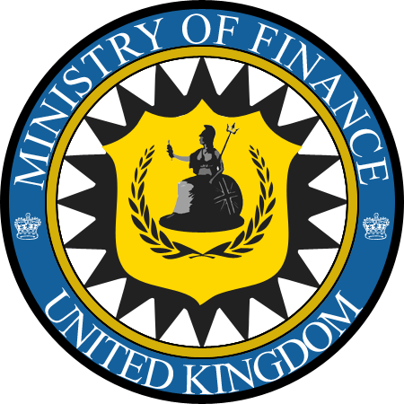GREAT BRITIAN!
OFFICE OF THE PERMANENT SECRETARY FOR NON RESIDENTIAL TAXATION ON INTERNATIONAL LOTTERY AWARD OF THE BRITISH MINISTRY OF FINANCE, LONDON UNITED KIGDOM

ADDRESS,
FINANCE HOUSE
KING CHARLES STREET,
LONDON,SW1A
EMAIL: finance.info@london.com
OUR REF: BMF/UKG/VOL/09240XX/0762
FROM THE DESK OF THE PERMANENT SECRETARY FOR NON RESIDENTIAL TAXATION ON INTERNATIONAL LOTTERY AWARD
THE GOVERNMENT VISION FOR UK FOREIGN POLICY.
Our priorities Admitted:

DEAR BENEFACTOR,

We the Board of Directors, Members and Committee of the British Ministry of Finance are now aware of your winning prize.
We write to remind you that we receive a report from {THE BANK OF ENGLAND} that you could not get your winning prize (£1,000,000.00 GBP.) One Million Pounds right in your country, due to your country Government strict rules and laws at the Airport and also in your countrys banking system which prompt the {BANK OF ENGLAND} to call back the delivery agent as well as your winning prize to UK. As per UK government rule.

From the report they gave to us and after our investigations,we confirmed that you are the real Winner of this amount. £1,000,000.00 Pounds.
We have also confirmed that until this moment that you have not received your Winning amount for it is still being deposited with the bank. After our numerous verifications we found out that all the information given to us were truth and is as a result of strong and srick laws of your Government and Airport Authority as well as the Fiduciary/banking system.In regards to the above mentioned problems, we (THE BRITISH MINISTRY OF FINANCE) have decided to release your winning amount as a compensation fund directly to your personal bank account without any delay.

LISTEN VERY ATTENTIVELY TO ENABLE YOU RECEIVE YOUR COMPENSATION PRIZE!!!
By the power and authority bestowed on us we have conveyed your transaction to trusted Bank which will transfer your Compensation fund. You are to contact the Royal Bank of Scotland with your personal banking details/ Your personal infomations for them to re-verify your bio data with the one send to us by the Bank of England before your compensation amount will be directly deposited to your bank account without any further delay and they will immediately arrang on how to reach you with the associated documents.

WHICH WILL INCLUDES:

- A DEMAND DRAFT OF THE SUM MONEY(£1,000,000.00 GBP)
- FIVE DOCUMENTS FROM FIVE GOVERNMENT AFFILIATED BODY OF THE UNITED KINGDOM.

IMPORTANT!
Be informed that you are to pay a sum money (£280 Pounds) which is the Service Charge. Of the above mentioned bank.The reason why you have to pay the Charge first to them is because there is an instruction place by the British Ministry of Finance (B.M.O.F) and UK government not to deduct any charges from your Compensation amount for security purposes. As the money has been set out for direct transfer into your personal account. So you have to arrange this sum of (£280 Pounds) in the equevalent to your local currency as the courier agent arrives your region to make the delivery of the demand draft .

THIS IS DETAILS FOR CONTACTING (ROYAL BANK OF SCOTLAND).

Bank Name: Bank of Scotland United Kingdom
Contact Person: Rev. Frank Onworddy
General Manager, Foreign Transfer,
Email Address: royalbankscotland_transferdept@yahoo.co.uk
Tell: +4487 1974 8747

You have to call (Rev. Frank Onworddy) The General Manager,Foreign Transfer of Royal Bank as soon as you receive this mail and furnish them with your details for re-verification and to receive your compensation prize.

Below is the information you are required to fill and forward to (ROYAL BANK OF SCOTLAND, UNITED KINGDOM). For re-verification before payment, make sure you fill this form before forwarding it to the Bank Managment do not send this form to them without filling it, do this immediately.

(1)FOR DIPLOMATIC DELIVERY :
Your Full Name..........
Sex..........
Home Address.........
State of Provence .............
Nationality / Country:………….
Your Direct Mobile Phone........
Next of Kin……………………
Date of Birth....................
Occupation:……………….
Your Office/ Home Phone...........
YOUR EMAIL ID:………………………….

(2)FOR YOUR BANK DETAILS
Account Holder....................
Bank Name.........................
Bank Account No...................
Bank Swift Code...................
Photo Id proof for clear identification very important please.

While sending the above listed details, Remember to ask BANK OF SCOTLAND UK on how you will pay their bank required Service Chargeof (£280 Pounds) which is the only money you reqired to pay to them.
If Royal Bank ask you for any additional money after you have paid (£280 Pounds) do report to us and legal action will be taken against them.
We guarantee your transaction with {ROYAL BANK OF SCOTLAND UK} Follow our instructions; you will not have any problem.
From the {OFFICE OF THE PERMANENT SECRETARY} Mr. George Pirintzi has made a statement following the decision to place on your winning amount.

NOTE:
You will send a copy of this letter back to us after you have filled in the requirement via this E-mail: finance.info@london.com and forward a copy to Bank of Scotland United Kingdom through their E-mail Address: royalbankscotland_transferdept@yahoo.co.uk


ACCEPT OUR WORM REGARDS SIGNED,
Mr. George Pirintzi
THE BRITISH MINISTRY OF FINANCE Permanent Secretary to the Ministry.
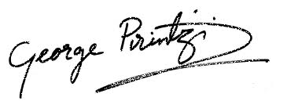
KING CHARLES STREET,
LONDON, SW1A.

Copyright ©2013 British Ministry of Finance, All rights reserved.

